**INSTRUCTION**

What is the object-oriented example?  
For example, say we created a class, Car, to contain all the properties a car must have, color, brand, and model. We then create an instance/behavior/method of a Car type object, myCar to represent my specific car.  
Could you please create another 5 object-oriented examples and give all their properties and their instances/behavior/method?

**SUBMISSION**

1. Use graphics to show the examples.
2. Use Word Documents and attached the file to your GitHub
3. Submit your link GitHub for this exercise into my GitHub before 25 Mac (Thursday) at 12.00 pm.

**Object-oriented example:**

1. **Refrigerators**

Type: Side-by-Side

Colour: Black

Feature: Family Hub

Behaviour:

1. Keeping Cool ()

2. Keep food safe ()

3. Store the food ()

Class:

Refrigerators

Properties:

1. Type

2. Colour

3. Feature

Type: Bottom Mount Freezer

Colour: Black

Feature: Digital Inverter Technology

Type: French Door

Colour: Brown

Feature: Triple Cooling

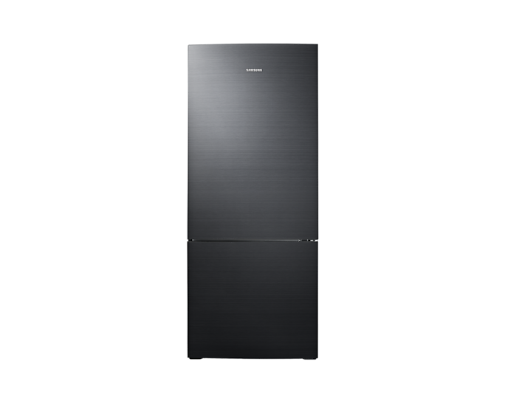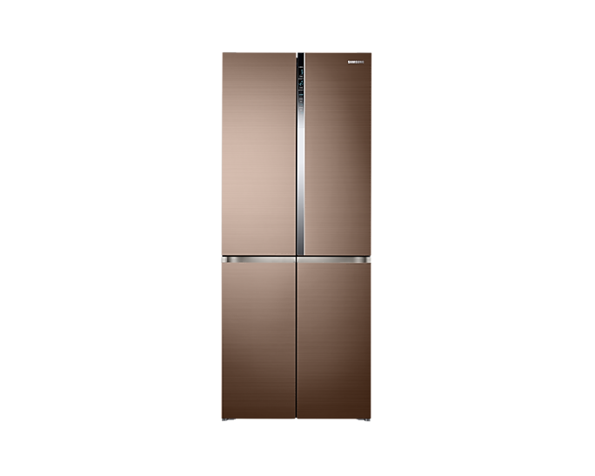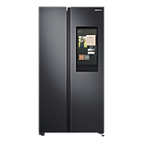

2. Tablets

Behaviour:

1. Youtube ()

2. Take picture ()

3. Notification ()

Brand: Huawei

Type: Huawei MatePad 10.4

Memory: 4GB+128GB

Colour: Midnight Grey

Properties:

1. Brand

2. Type

3. Memory

4. Colour

Class: Tablets

Brand: Apple

Type: Apple iPad 10.2

Memory: 32GB+3GB

Colour: Black

Brand: Samsung

Type: Samsung Galaxy Tab A7

Memory: 32GB+3GB

Colour: Silver

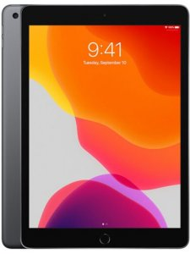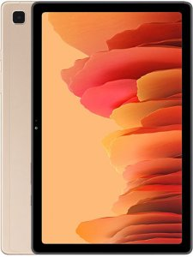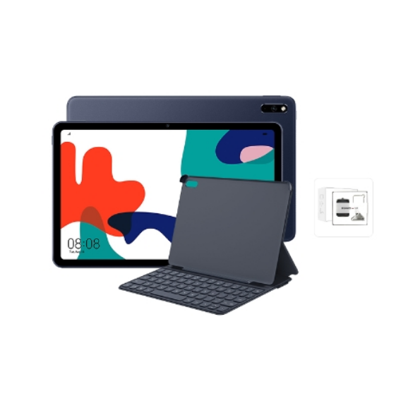

3. Earphone

Behaviour:

1. Listen to the music ()

2. Calling ()

Properties:

1. Brand

2. Type

3. Features

4. Connection

Class: Earphone

Brand: Sony Wireless Headphone SNY-WHCH510/BZE

Type: Wireless Headphone

Features: All-day listening with quality sound

Connection: Bluetooth

Brand: Apple

Type: Apple EarPods

Featured: Deeper, Richer Bass Tones

Connection: Lightning Connector

Brand: HUAWEI FreeLace Amber Sunrise

Type: Wireless Earphone

Features: Memory Metal Cable Fit and Flexible

Connection: Bluetooth

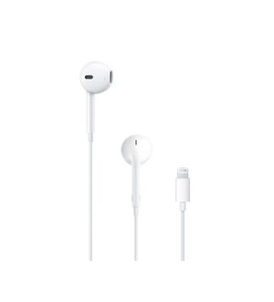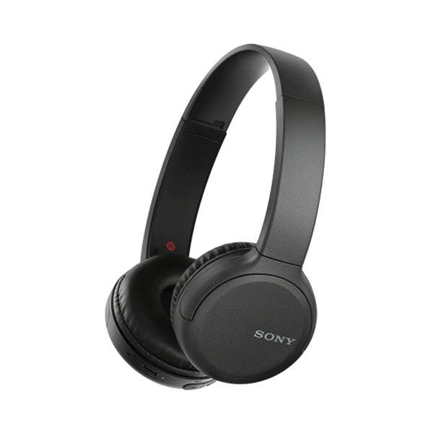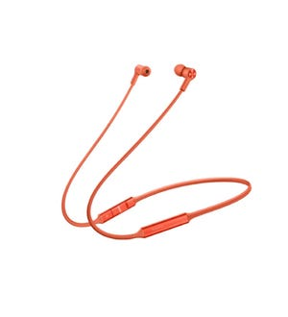

4. Air-Conditioner

Behaviour:

1. Cool Place to Sleep ()

2. Less Insects and Parasites ()

3. Reduces the Risk of Dehydration ()

Properties:

1. Brand

2. Type

3. Features

Class: Air-Conditioner

Brand: Toshiba

Type: 1.5HP Inverter Air Conditioner RAS-13U2KCVG

Featured: Double Clean System

Brand: Hitachi

Type: 1.5HP R32 Deluxe Inverter Air Conditioner HTC-RASSH13CKM

Features: Energy saving

Brand: Panasonic

Type: CS-U13VKH 1.5HP Premium Inverter Aero Series

Features: Fast cooling

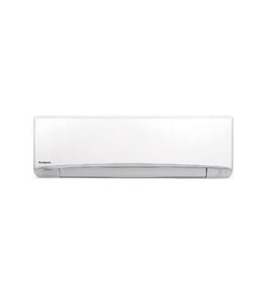

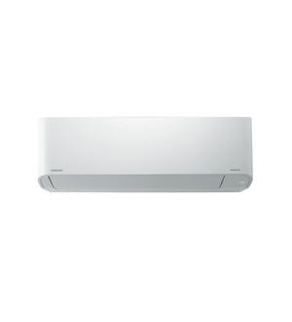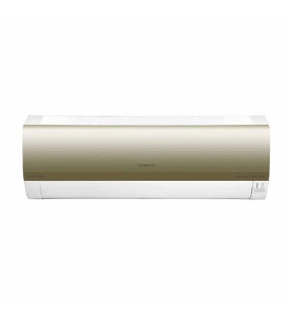

5. Chicken

Behaviour:

1. Eating ()

2. Laying eggs ()

Properties:

1. Breed

2. Size

3. Colour

Class: Chicken

Breed: Silkie

Size: Medium

Colour: Brown

Breed: Naked Neck

Size: Medium

Colour: Gold

Breed: ISA Brown

Size: Medium

Colour: Black & White

